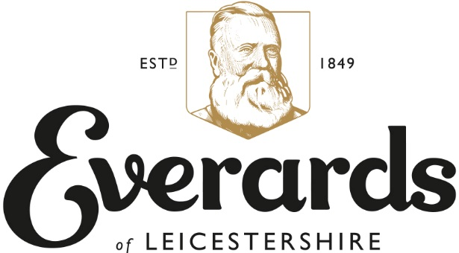

Landlord Testimonial

A testimonial from the departing Collyweston Slater landlord Adam Weeks…

“We have thoroughly enjoyed our three years at the slater. The pub is in a great location and is frequented by a brilliant locals trade who are welcoming and friendly. Our partnership with Everards has been fantastic. Whenever we needed some support they offered it to us in abundance. When we needed advice, the knowledgeable team was able to offer expert and detailed support, which was a great help. The beer technicians were always on hand if any problems arose in the cellar and were often out to sort it in just a few hours.

I cant praise Everards enough for how much easier they have made the last three years for us whilst being at the pub. In the future I would have no hesitation partnering with them again”.
